*LAB # 02*

VARIABLES AND OPEARTORS

# *OBJECTIVE:*

*Implement different type of data types, variables and operators used in Python.*

HOME task

**EXERCISE**

1. ***Point out the errors, if any,and also paste the output in the following Python statements.***

x=5:

print(x)

**Code:**

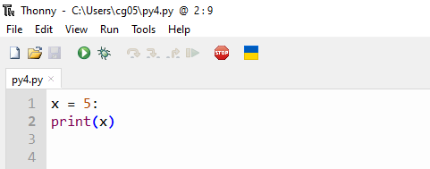

**Output(error):**

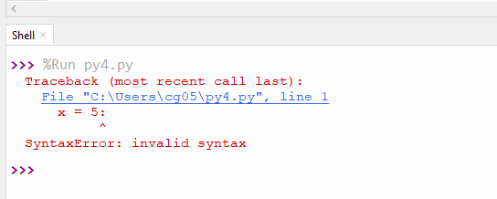

**Correct Code is:**

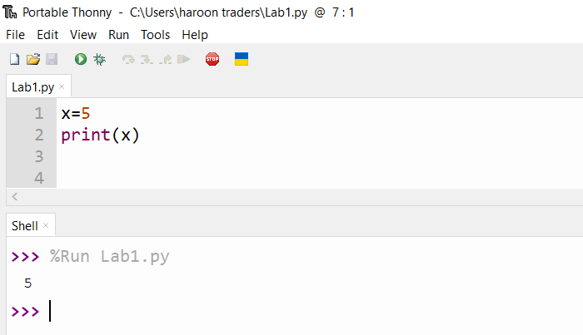

1TEXT = "SSUET"

NUMBER = 1

print(NUMBER+ TEXT)

**Code:**

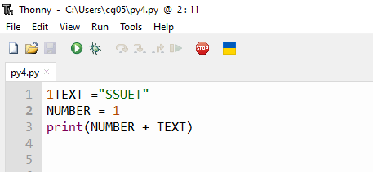

**Output(error):**

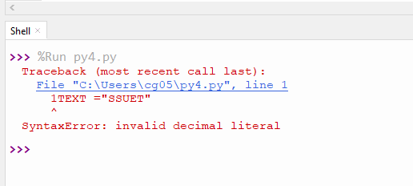

**Correct Code is:**

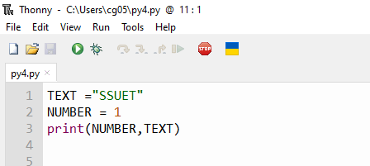

**Output**

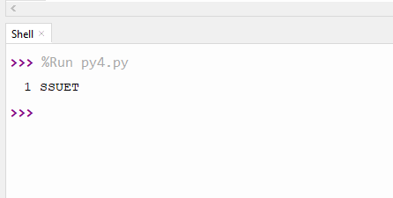

**Code:**

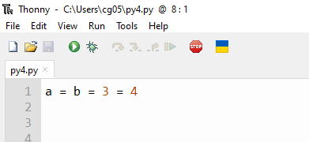

**Output(error):**

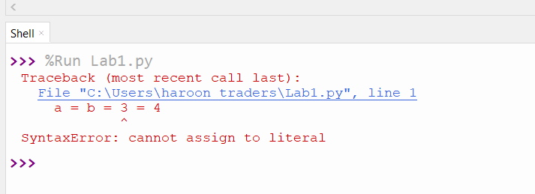

**Correct Code is:**

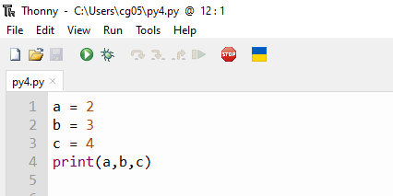

**Output:**

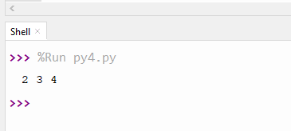

1. ***Evaluate the operation in each of the following statements, and show the resultant value after each statement is executed.***

* **a = 2 % 2 + 2 * 2 - 2 / 2;**

**Code:**

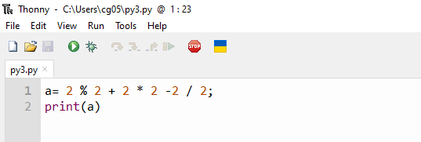

**Output:**

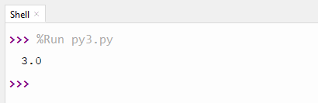

* **b = 3 / 2 + 5 * 4 / 3 ;**

**Code:**

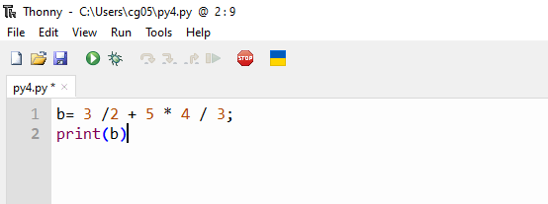

**Output:**

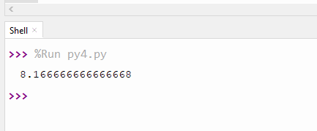

**c = b = a = 3 + 4 ;**

**Code:**

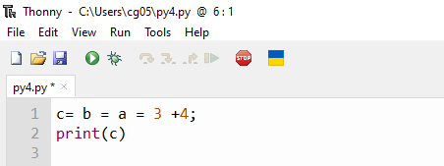

**Output:**

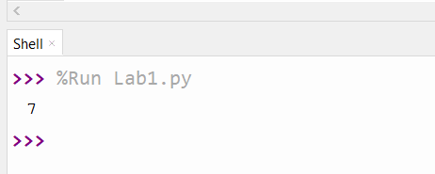

1. ***Write the following Python programs****:*
2. *Write a program that calculates area of a circle $A=πr^{2}$. (Consider r = 50).*

**Code:**

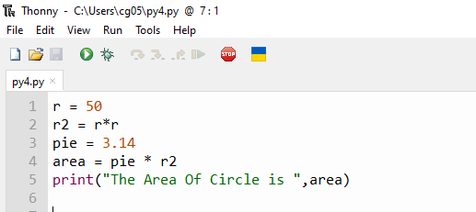

**Output:**

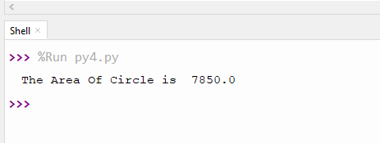

1. *Write a program that performs the following four operations and prints their result on the screen.*

* 50 + 4

**Code:**

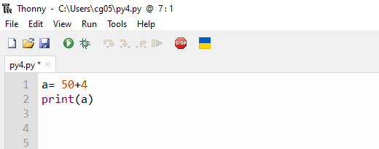

**Output:**

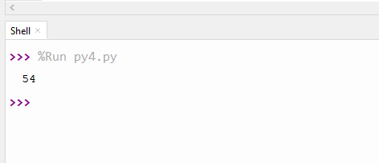

* 50 – 4

**Code:**

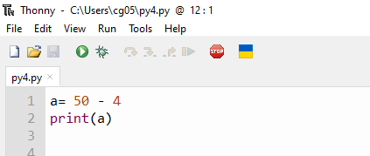

**Output:**

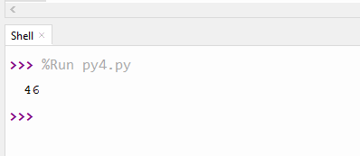

* 50 * 4

**Code:**

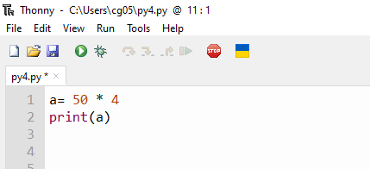

**Output:**

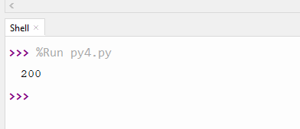

* 50 / 4

**Code:**

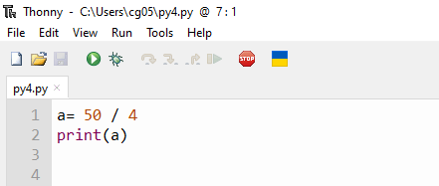

**Output:**

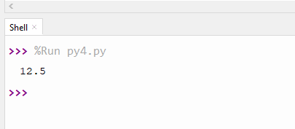

***3. Write a Python program to convert height (in feet and inches) to centimeters. Convert height of 5 feet 2 inches to centimeters.***

* ***First, convert 5 feet to inches: 5 feet × 12 inches/foot = 60 inches***

**Code:**

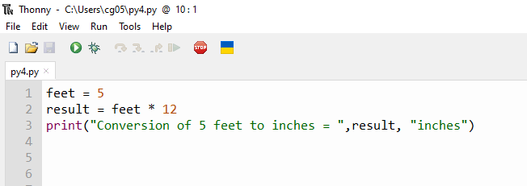

**Output:**

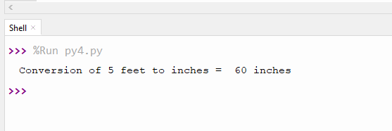

* ***Add up our inches: 60 + 2 = 62 inches***

**Code:**

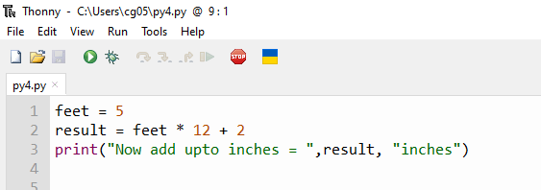

**Output:**

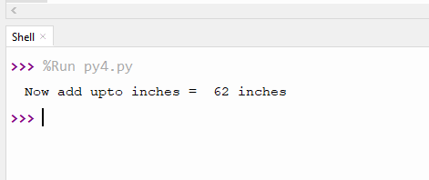

* ***Convert inches to cm: 62 inches × 2.54 cm/inch = 157.48 cm***

**Code:**

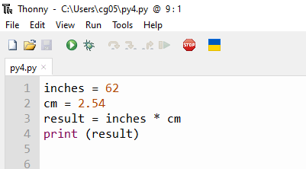

**Output:**

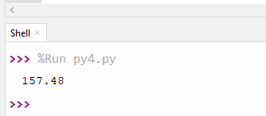

**4**. *Write a program to compute distance between two points by creating variables (Pythagorean Theorem)*

***Distance =((x2−x1)^2+(y2−y1)^2)^1/2***

**Code:**

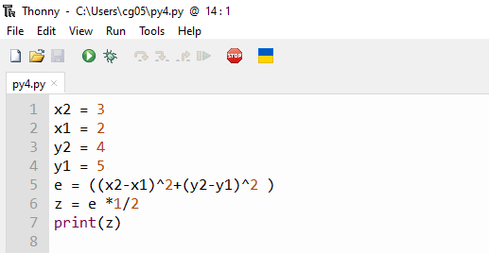

**Output:**

